

**Power BI and Excel – Better Together**

Demo Script

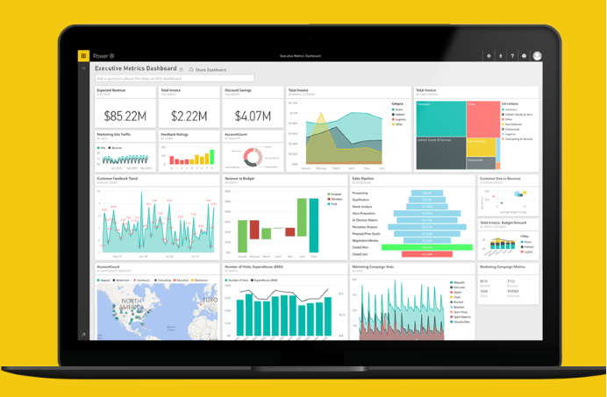

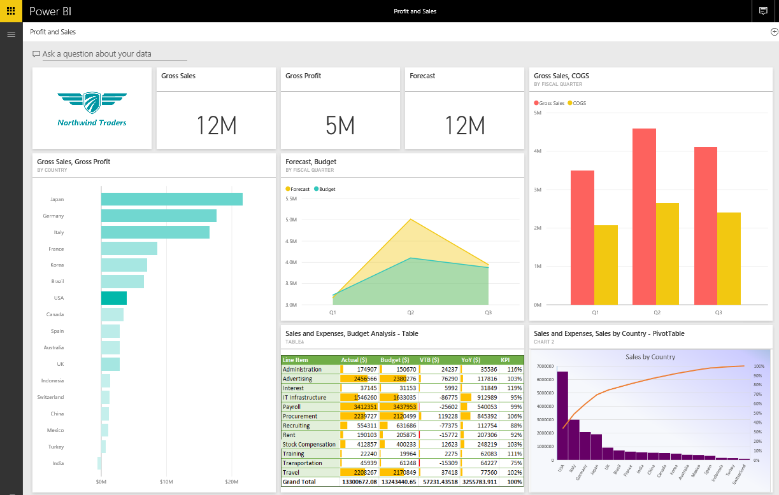

August 2016

# Contents

Contents 2

About this demo 3

Prerequisites 3

Part 1 – Prepare data in Excel 5

Part 2 – Import an Excel file 10

Part 3 – Upload an Excel file 15

Part 4 - Analyze in Excel 18

Part 5 - Import a Power BI Desktop file (optional) 20

Part 6 – Pin from Excel (optional) 23

Conclusion 24

# About this demo

Microsoft Excel is one of the most widely used business applications around. It is also one of the most common ways to get your data into Power BI. Use this demo to showcase how Power BI and Excel are deeply connected and how well they work together.

# Prerequisites

| Prerequisite | Screenshot |
| --- | --- |
| 1. **Prerequisite**: You will need a Power BI account for this demo. If you do not have an account, you can sign up for free at <http://powerbi.com> |  |
| 1. **Prerequisite**: You will need Power BI Desktop installed on your machine.   Visit <http://powerbi.microsoft.com/desktop> to install the latest version of Power BI Desktop. |  |
| 1. **Prerequisite:** You will need to install the **Analyze in Excel updates** for Power BI as described below.    1. Sign in with your Power BI account at powerbi.com.    2. In the navigation pane, select **Analyze in Excel** from the menu (...) next to one of your existing reports or datasets.    3. When you first use **Analyze in Excel**, you need to install updates to the Excel libraries. You’ll be prompted to download and run the installation for the Excel updates (Windows installer package **SQL_AS_OLEDDB.msi**).    4. Run the installer file file **SQL_AS_OLEDDB.msi** once it is downloaded.    5. Follow the setup wizard to complete the installation.    6. Back in Power BI, select **Analyze in Excel** again.    7. Power BI will create an .ODC file and download it to your computer. |  |
| 1. **Prerequisite (optional):** You need to install the **Power BI publisher for Excel** to complete the optional portion **Pin from Excel** of this demo.    1. Download Power BI publisher for Excel at <https://powerbi.microsoft.com/en-us/excel-dashboard-publisher>    2. Run the installer file **PowerBIpublisher_[..][..].msi** once it is downloaded.    3. Follow the setup wizard to complete the installation. |  |

# Part 1 – Prepare data in Excel

| Narrative | Steps | Screenshot |
| --- | --- | --- |
| Let me step into the role of a business analyst for this demo. My work is focused on analytics, statistics, visualization and presentation. I am expected to provide consumable data to others in my organization. Excel is an important tool for me to bring data together from different sources, model that data and use PivotTables and charts to analyze and visualize the data.  The nice thing about Power BI is that I can use all the data, models and charts that may already exist somewhere in Excel workbooks directly in Power BI. Not only that, Power BI is valuable and familiar to me. Let me show you how.  I am in a standard Excel workbook that I prepared for my Finance team. It contains tables, KPIs, PivotTables, and charts.  As an analyst, I import data from different sources into Excel. I’ve done this for years and Excel has become an invaluable tool for me for everything from importing data to creating a data model with relationships. In Excel, these are the tools known as Power Query and Power Pivot.  Any Excel-savvy analysts who has been using these tools in Excel will feel comfortable jumping into Power BI. You only need to learn how to do this once.  So let me import some data into Excel. | 1. Open the Excel file **Sales and Expenses.xlsx** that is delivered with this demo. The file contains two sheets:    * **Sales by Country – PivotTable**    * **Budget Analysis – Table** 2. Select the **Data** tab in the Excel ribbon, then select **New Query** **-> From File -> From Workbook**. 3. Select the file **SalesOpexData.xlsx** that is delivered with this demo, then click **Import**. |  |
| I get a preview of my data and using the Edit function, I can further manipulate the data before I complete the import. | 1. Check **Select Multiple Items,** then select **CountryTable**, **OperatingExpensesTable** and **SalesTable**. 2. Click on **Edit**. |  |
| With Power Query I have an intuitive experience for discovering, combining, and refining data across a wide variety of sources. I get a consistent experience using the Query functionality in Power BI Desktop. | 1. The **Query Editor** will be shown. 2. On the left, select the **SalesTable** query. 3. In the data preview, scroll to the right and select the columns **Gross Sales, Budget, Forecast, Net Sales, COGS** and **Gross Profit** (use **CTRL** or **SHIFT** to multi-select). |  |
| I have the ability to shape the data from my data sources, for example I can change the data type of selected columns in my dataset. | 1. Right-click on one of the selected columns, then select **Change Type** -> **Currency**. |  |
| Once I have my data in the shape that I want it, I can finish my data load into Excel.  I can load the data into a table and can choose whether I want to create a data model. | 1. From the **Home** tab, select the drop down for **Close & Load**, then select **Close & Load To**. 2. In the **Load To** dialog, select the options **Only Create Connection** and **Add this data to the Data Model**. 3. Select **Load**. |  |
| So what did I do with just a few clicks?  I ran 3 queries that imported and transformed data from another Excel workbook into a data model. | 1. You can see the results of the data import in the **Workbook Queries** pane. |  |
| Let’s look at the data model. | 1. From the **Data** tab, select **Manage Data Model** 2. **Power Pivot for Excel** will launch. |  |
| I can have relationships in our data model which will be important later on to properly analyze or visualize the data. | 1. In the ribbon, select **Diagram View** to manage the relationships between the imported tables. |  |
| Our tables are related on the country field from the country table. | 1. Drag the **Country** field from **CountryTable** over the **Country** field in **SalesTable**. 2. Drag the **Country** field from **CountryTable** over the **Country** field in **OperatingExpensesTable**. 3. Click on **Save As** and save the Excel file as **ExcelPBIDemo.xlsx** to your local machine. 4. Close **Excel**. |  |

# Part 2 – Import an Excel file

| Narrative | Steps | Screenshot |
| --- | --- | --- |
| As a business analyst, I just used Excel to create a data model with financial data. My finance team has started to use Power BI to enable monitoring and analysis for the entire finance organization. I want to bring the financial data model that I just created in Excel into this experience so that my business users can work with it.  Power BI allows me to import or connect to Excel files that have been created in Excel 2007 or later.  In this first demo, we will use the import function.  Let’s see what it does. | 1. Navigate to <http://powerbi.com> and sign in with your account. 2. Create a new Power BI dashboard named **Excel Power BI Demo**. 3. In the left navigation pane, select **Get Data**. 4. Under **Files**, select **Get**. | https://dpspowerbi.blob.core.windows.net/powerbi-prod-media/powerbi.microsoft.com/en-us/documentation/articles/powerbi-service-get-started/20160503062100/getdata3.png |
| Our Excel file is local, I can simply browse to it and open it. | 1. Select **Local File.** 2. Browse to the Excel file that you saved previously (Part 1 of this demo), then select **Open**. | https://dpspowerbi.blob.core.windows.net/powerbi-prod-media/powerbi.microsoft.com/en-us/documentation/articles/powerbi-service-get-started/20160503062100/gs2.png |
| When I choose to import my Excel data, any supported data in tables and/or a data model are imported into a new dataset in Power BI.  I choose this option whenever I use Power Query or Power Pivot to load data into an Excel data model. | 1. On the **Local File** page, select **Import**. |  |
| The data model is now imported into Power BI and I can start to create a report for my business users. | 1. The new dataset will be shown in the Power BI navigation pane, with the name of the Excel file i.e. **ExcelPBIDemo**. 2. Click on the dataset **ExcelPBIDemo** to open a blank report. |  |
| Another nice benefit of having this data model in Power BI is that my business users can use the Q&A feature to ask questions of their data. | 1. Navigate back to the new dashboard. 2. Type some questions in the field **Ask question about your data**:   **show total gross profit**  **show total gross profit by country** |  |
| You can see how Power BI is guiding me with suggested terms that I can use in my question, based on the data set and data model that I prepared in Excel. | 1. Refine the question:   **show total gross profit by country by product category**   1. Click on **Pin visual** |  |
| Once I have an insight and visual that I like, I can pin it to my dashboard. | 1. Further refine the question:   **show profit by channel by product as treemap**   1. Click on **Pin visual** above the chart to the treemap to the dashboard. |  |
| [Optional] Let’s add a nice visualization showing sales and profit across region and countries. This is something my business users can do in Power BI, with the data model that I created for them.  As before, once I like how a chart looks, I can pin it to a dashboard. Let’s create a new dashboard for this demo. | 1. In the Power BI navigation pane, click on the dataset **ExcelPBIDemo** to return to your blank report. 2. In the **Visualizations** pane, select the **Stacked bar chart**. 3. In the **Fields** pane, expand the **SalesTable** and add the fields **Region** and **Country** to the **Axis** area. 4. Add the field **Gross Sales** to the **Value** area. 5. Add the field **Gross Profit** to **Color saturation.** 6. Use the **drill all** function at the top of the chart (double arrows) to drill to the country level. 7. Use the menu at the top right of the chart (…) to **Sort By Gross Sales**. 8. Clickon the pin icon to pin this visual to your dashboard. 9. When prompted, save your report as **Profit and Sales**. 10. Pin the visual to a new dashboard that you can also name **Profit and Sales**. |  |
| My business users love this feature, it allows them to find new insights and create their own dashboards. | 1. Go back to the dashboard. Resize and rearrange tiles as shown. |  |

# Part 3 – Upload an Excel file

| Narrative | Steps | Screenshot |
| --- | --- | --- |
| You just saw how I used the Import function in Power BI to load a data model that I prepared in Excel.  Let me show you another way to use Excel workbooks into Power BI – this time using the Upload function. | 1. Navigate back to the new dashboard that you created. 2. In the left navigation pane, select **Get Data**. 3. Under **Files**, select **Get**. | https://dpspowerbi.blob.core.windows.net/powerbi-prod-media/powerbi.microsoft.com/en-us/documentation/articles/powerbi-service-get-started/20160503062100/getdata3.png |
| Again, I am using the Get Data function in Power BI to browse to my local Excel file. | 1. Select **Local File.** 2. Browse to the **ExcelPBIDemo.xlsx** file that is provided with this demo, then select **Open**. | https://dpspowerbi.blob.core.windows.net/powerbi-prod-media/powerbi.microsoft.com/en-us/documentation/articles/powerbi-service-get-started/20160503062100/gs2.png |
| This time I will upload the file, not import it.  When you upload an Excel file to Power BI, you can interact with the Excel file just as you would in Excel Online. Let’s see how it works. | 1. On the **Local File** page, select **Import**. |  |
| The uploaded Excel file will appear in the Reports section in Power BI, together with my other Power BI reports, and with an Excel icon next to it. | 1. In the **Reports** section of the navigation pane, click on the **ExcelPBIDemo** report. |  |
| My business users now have the complete workbook in Power BI now and they can work with it just as they would in Excel Online. | 1. The Excel file will open in **Excel Online** within Power BI. 2. Select the **Budget Analysis – Table** worksheet. 3. Select all cells of the table, then use the **Pin** command to pin it to the existing dashboard. |  |
| I can select a chart and pin that to my dashboard.  Or, I can select a range of cells and pin them to my dashboard. | 1. Select the **Sales by Country – PivotTable** worksheet. 2. Pin **Sales by country** chart. |  |
| This is no longer a static image that I pinned to my dashboard. I can click on the Excel object to go back into my workbook in Excel Online.  That’s awesome! | 1. Arrange the Excel table and pivot chart as shown. 2. Click on either the Excel table or the pivot chart and notice how it will take you back into the underlying Excel report. |  |

# Part 4 - Analyze in Excel

| Narrative | Steps | Screenshot |
| --- | --- | --- |
| You have just seen some great examples of how easy it is for me as the Business Analyst to bring the data and models that I’ve created in Excel into Power BI.  That’s great, but what if I have a dataset in Power BI that I want to analyze in Excel, using familiar features and functions?  No problem - I am glad you asked.  Analyze in Excel in Power BI allows me as the Business Analyst to connect to a Power BI dataset or report from Excel to analyze the data.  Analyze in Excel is very useful to me for datasets and reports that are connected to Analysis Services Tabular or Multidimensional databases, or from Power BI Desktop files or Excel workbooks with data models that have explicit measures created using Data Analysis Expressions (DAX). | 1. In the Power BI navigation pane, locate the **ExcelPBIDemo** dataset and select the menu (**…**) next to it. 2. From the menu, select **Analyze in Excel**. 3. Power BI will create an .ODC file and download it from the browser to your computer. 4. Open the .ODC file in Excel. |  |
| When you analyze or work with the data, Excel queries that dataset in Power BI and returns the results to Excel. The .ODC (or connection) file contains an MSOLAP connection string that connects Excel to your dataset in Power BI. | 1. In the security notice dialog, select **Enable**. |  |
| To access the Power BI dataset, I need to authenticate the connection.  Although I am signed in to Power BI in my browser, the first time I open a new .ODC file in Excel, I have to sign in to Power BI with my credentials. | 1. If you are not already signed into Power BI, sign in with your credentials. |  |
| Excel will launch and show a blank PivotTable that is connected to the Power BI dataset. Now I am ready to do all sorts of analysis on your Power BI dataset, using my familiar Excel features! | 1. The **PivotTable Tools** in Excel will be shown, with the fields from the Power BI dataset shown in the **PivotTable Fields** pane. |  |

# Part 5 - Import a Power BI Desktop file (optional)

| Narrative | Steps | Screenshot |
| --- | --- | --- |
| As a Business Analyst, I can use Power BI Desktop to connect to many different data sources, query and transform the data, model the data, and creating powerful and dynamic reports easily.  The best part is, as a savvy Excel user, Power BI Desktop is immediately familiar and useful to me. | 1. Navigate back to the new dashboard that you created. 2. In the left navigation pane, select **Get Data**. 3. Under **Files**, select **Get**. | https://dpspowerbi.blob.core.windows.net/powerbi-prod-media/powerbi.microsoft.com/en-us/documentation/articles/powerbi-service-get-started/20160503062100/getdata3.png |
| Just as before, I can use the Get Data function in Power BI to import a Power BI Desktop, or PBIX file. | 1. Select **Local File.** 2. Browse to the **Sales and Profitability.pbix** file that is provided with this demo, then select **Open**. | https://dpspowerbi.blob.core.windows.net/powerbi-prod-media/powerbi.microsoft.com/en-us/documentation/articles/powerbi-service-get-started/20160503062100/gs2.png |
| The experience is very similar to when I imported the Excel file before. This enables my business users to import a file with a data model and visuals that I created for them. | 1. A new tile representing the **Sales and Profitablity.pbix** file will be added to the dashboard and a message will confirm the import of the file. 2. Click on the tile for **Sales and Profitablity.pbix**. |  |
| In a Power BI Desktop file, there are likely already some reports with visualizations that the business users can easily pin to a dashboard. | 1. Select the **COGS and Forecast** report page. 2. Click on the pin icon of the **Gross Profit** card. |  |
| I can choose to pin a visual to an existing dashboard, or create a new one. | 1. Pin the card to the **Existing** **Dashboard**. |  |
| Let’s pin a two additional cards to our dashboard. | 1. Pin the **Gross Sales** and **Forecast** cards to the same dashboard. |  |
| Let’s also pin these charts to make our dashboard a little more interesting. | 1. Pin the three charts on the report page to the same dashboard. |  |
| Finally, let’s add our company logo from the Images report page. And voila – with only a few clicks, here is our Profit and Sales dashboard. | 1. Select the **Images** report page. 2. Pin the Northwind trader’s logo to the dashboard. 3. Resize and rearrange the tiles on the dashboard as shown on the right. |  |

# Part 6 – Pin from Excel (optional)

| Narrative | Steps | Screenshot |
| --- | --- | --- |
| Let me show you one more scenario that shows the deep integration between Power BI and Excel.  I am back in my standard Excel workbook that I prepared for my Finance team. As you remember, it contains tables, KPIs, PivotTables, and charts.  I would like to share this chart with the broader Finance team on a dashboard.  With the Power BI publisher for Excel installed, I now have a Power BI tab on my Excel ribbon.  What I can do is simply select a chart in Excel and pin it to my Power BI dashboard. | 1. Open the Excel file **Sales and Expenses.xlsx** that is delivered with this demo. The file contains two sheets:    * **Sales by Country – PivotTable**    * **Budget Analysis – Table** 2. Select the sheet **Sales by Country - PivotTable**. 3. Click on the chart titled **Sales by Country.** 4. From the **Power BI** ribbon, select **Pin** to pin the visual to a Power BI dashboard. 5. If you have already pined this tile choose **Add tile** option and click **OK**. |  |
| I can choose where I want to pin the image to. I will select my default workspace and a new dashboard.  It’s that easy! | 1. When prompted, sign in with your Power BI account. 2. Select **Excel Power BI Demo** dashboard carted in the part 2 section of this demo (or the **Workspace** and **Dashboard** to which you want to pin this visual). 3. Click on **OK**. |  |
| Great, now the chart image has been pinned to my dashboard and I can share the dashboard with my business users.  Note however that this feature works different than what we saw before when we uploaded the Excel workbook to Power BI. I am not able to click on my chart in Power BI to navigate into the underlying Excel report. The chart is added as a static image to my dashboard. | 1. You will see a confirmation message and a tile representing the Excel dataset. |  |

# Conclusion

Use this demo to showcase how Power BI and Excel are deeply connected and how well they work together. For the Excel-savvy Business Analyst, Power BI will be valuable and familiar.

©2016 Microsoft Corporation. All rights reserved.

By using this demo/lab, you agree to the following terms:

The technology/functionality described in this demo/lab is provided by Microsoft Corporation for purposes of obtaining your feedback and to provide you with a learning experience. You may only use the demo/lab to evaluate such technology features and functionality and provide feedback to Microsoft. You may not use it for any other purpose. You may not modify, copy, distribute, transmit, display, perform, reproduce, publish, license, create derivative works from, transfer, or sell this demo/lab or any portion thereof.

COPYING OR REPRODUCTION OF THE DEMO/LAB (OR ANY PORTION OF IT) TO ANY OTHER SERVER OR LOCATION FOR FURTHER REPRODUCTION OR REDISTRIBUTION IS EXPRESSLY PROHIBITED.

THIS DEMO/LAB PROVIDES CERTAIN SOFTWARE TECHNOLOGY/PRODUCT FEATURES AND FUNCTIONALITY, INCLUDING POTENTIAL NEW FEATURES AND CONCEPTS, IN A SIMULATED ENVIRONMENT WITHOUT COMPLEX SET-UP OR INSTALLATION FOR THE PURPOSE DESCRIBED ABOVE. THE TECHNOLOGY/CONCEPTS REPRESENTED IN THIS DEMO/LAB MAY NOT REPRESENT FULL FEATURE FUNCTIONALITY AND MAY NOT WORK THE WAY A FINAL VERSION MAY WORK. WE ALSO MAY NOT RELEASE A FINAL VERSION OF SUCH FEATURES OR CONCEPTS. YOUR EXPERIENCE WITH USING SUCH FEATURES AND FUNCITONALITY IN A PHYSICAL ENVIRONMENT MAY ALSO BE DIFFERENT.

**FEEDBACK**. If you give feedback about the technology features, functionality and/or concepts described in this demo/lab to Microsoft, you give to Microsoft, without charge, the right to use, share and commercialize your feedback in any way and for any purpose. You also give to third parties, without charge, any patent rights needed for their products, technologies and services to use or interface with any specific parts of a Microsoft software or service that includes the feedback. You will not give feedback that is subject to a license that requires Microsoft to license its software or documentation to third parties because we include your feedback in them. These rights survive this agreement.

MICROSOFT CORPORATION HEREBY DISCLAIMS ALL WARRANTIES AND CONDITIONS WITH REGARD TO THE DEMO/LAB, INCLUDING ALL WARRANTIES AND CONDITIONS OF MERCHANTABILITY, WHETHER EXPRESS, IMPLIED OR STATUTORY, FITNESS FOR A PARTICULAR PURPOSE, TITLE AND NON-INFRINGEMENT. MICROSOFT DOES NOT MAKE ANY ASSURANCES OR REPRESENTATIONS WITH REGARD TO THE ACCURACY OF THE RESULTS, OUTPUT THAT DERIVES FROM USE OF DEMO/ LAB, OR SUITABILITY OF THE INFORMATION CONTAINED IN THE DEMO/LAB FOR ANY PURPOSE.

**DISCLAIMER**

This demo/lab contains only a portion of new features and enhancements in Microsoft Power BI. Some of the features might change in future releases of the product. In this demo/lab, you will learn about some, but not all, new features.